What’s digital about Digital Humanities?

# Introduction

Fifteen years ago, I was participating to a digital humanities’ “unconference.”[1] Among the many topics discussed, the participants wondered if ‘analog’ and ‘digital’ humanities would one day converge. One answer emerged: not without traditional humanities adopting digital humanities’ practices such as unconferences, open access, open data and so on. Those practices were not all digital *per se*. Some were induced using digital tools, essentially digital computers and software, but others seemed rooted in diverging cultures. Wikis, for instance, did not invent collaboration. After all, digital humanities did not only relate to Humanities and computing – there was something more, linked to what might be termed as culture.

What’s digital in Digital Humanities? The answer may seem obvious, but the previous anecdote demonstrates that it is not, that it could relate to some sort of cultural habits or values as Lisa Spiro argued[2] and not only to something *digital*. The two words and their combination bear ambiguities and ambivalences. Both come from Latin, but neither has an easy definition nor a stable one through their history, all the more that there are variations from one country to the other. The evolution in the meaning of *digital* – related to fingers and by extension numbers– after 1943, when it became related to computer technology, contrasts with the concept of *humanities*, that relates to strong academic and educational Western traditions. Digital humanities confronts both: centuries old traditions and relatively recent developments spanning a few decades.

Questioning the digitality of digital humanities involves scrutinizing these definitions and temporalities and their interplay within the term “digital humanities”. In *The Archived Web*, Niels Brügger notes that many publications about “’digital’ and ‘X’”[3] have been published, without much reflection on what *digital* means. If we stand from a particular use of electricity that is at the center of the binary system that is a computer, *digital* means the use of ‘0’ (no electricity) and ‘1’ (electricity) as an alphabet.[4] The problem of such a definition of *digital* is that 0/1 are to be seen as building blocks. Let’s then follow Brügger:

In the present context, the term digitality is used to capture the specific ways in which the digital bits are materialized and combined in a concrete media artifact and in concrete texts.

So, what’s the digitality of Digital Humanities? How did (still do) Digital Humanities set up specific ways to transform digital bits, to materialize them into concrete artefacts, and maybe more cultural ones, which is part of Milad Doueihi’s argumentation[5]? In a way, we will try to answer Thomas Haigh question in his chapter about Nicholas Negroponte: “What implicit definitions of digitality are hidden in the rhetoric of the digital humanities, and how have they changed over time?”

There are canonical definitions of Digital Humanities, the oldest one being in *A Companion to Digital Humanities* (2004):

Especially since the 1990s, with the advent of the World Wide Web, digital humanities has broadened its reach, yet it has remained in touch with the goals that have animated it from the outset: using information technology to illuminate the human record, and bringing an understanding of the human record to bear on the development and use of information technology.[6]

This definition – that also describes the transition from humanities computing to digital humanities – outlines how the advent of the web allowed Humanities Computing and then Digital Humanities to broaden their scope. However, this provides limited insight into the digitality of digital humanities, as it links the definition of ‘digital’ to information technologies, which might explain the numerous definitions of DH that can be found online.

For instance, using a database of *Day of DH* quotes - a yearly event mobilising the DH community –, Jason Heppler created the website [*What is Digital Humanities*](https://whatisdigitalhumanities.com) that showcases around 800 different definitions of DH.

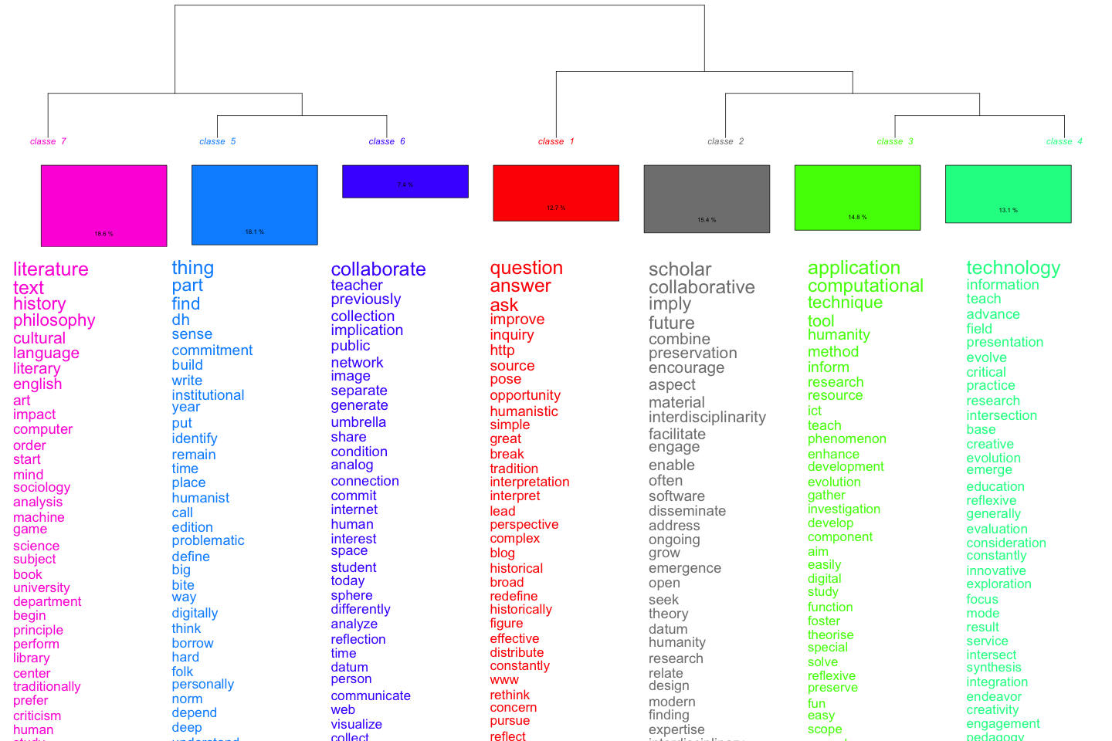

Clustering (Hierarchical descending Clustering, based on Max Reinert’s work[7] as implemented in the [iramuteq](https://iramuteq.org) application)

Figure 1 is a distant reading (a quantitative approach) of those definitions of digital humanities - and there is not much about digitality. Where are 0s and 1s? In the end, these diverse definitions of Digital Humanities do not answer our question. Might the collective memory of the DH community provide an answer?

# DH collective memory and digitality

When referring to *history* here, I do not mean an academic history of DH[8], but consider more a sort of collective memory[9] shared among members of the DH community.

The usual narration of this history starts with a 1946 meeting between Roberto Busa, a Jesuit indexing the work of Thomas Aquinas, and IBM chairman, Thomas J. Watson. Roberto Busa passed away in 2011 at 97, living long enough to contribute a foreword to *A Companion to Digital Humanities*.[10]

Busa’s project, the *Index Thomisticus*, ultimately indexed more than 10 million words, in 56 volumes published between 1974 and 1980. The *Index Thomisticus* was a *digital* project – in the sense that it used *digital* machines, initially mainframes – with inputs in the form of punch cards or magnetic tape and printed paper outputs (books). The project was then transformed into a CD-ROM (1992) and then a website (2005). Over time, then, the process shifted from one aimed at the production of printed, human readable indexes to the generation of electronic texts accessible only via the mediation of computer technology. It has taken on aspects of a myth: a key person, an influence over several generations, the insistence on text and on ways to transform text into something that can be computed and structured (lemmatization, concordances, etc).

Additional milestones in the conventional history of the digital humanities include the creation of two associations - the Association for Literary and Linguistic Computing (ALLC) in 1973 (today, the European Association for Digital Humanities) and the Association for Computer in the Humanities (1978), the former being more European and the latter predominantly North American. From 1988, the two associations organized a joint annual conference. Together with the Association for Computational Linguistics, both created the Text Encoding Initiative (TEI) consortium – a major player in humanities computing and, today, in digital humanities that highlights how humanities computing was rooted into the study of text. The TEI has as a main mission to encourage the encoding and semanticization of the digital version of texts via a common markup language. The strong influence of computational linguistics as well as English departments is often emphasized here[11]. In itself, the work within and between associations is a rather classical academic one. A more digital step in this history is the creation of the [*Humanist* Discussion Group](https://www.dhhumanist.org/) – *Humanist* and not *Digital Humanist* nor *Conmputatinal Humanist* nor… – by [Willard McCarthy](https://www.mccarty.org.uk/), that still serves as a central hub for discussing DH.

Around 2004, the rhetorical switch from *humanities computing* to *digital humanities* started with the publication of the *Blackwell Companion to Digital Humanities*, edited by Susan Schreibman, Ray Siemens and John Unsworth. In their introduction, the editors present the book as a turning point in digital humanities because “for the first time, a wide range of theorists and practitioners, those who have been active in the field for decades, and those recently involved, disciplinary experts, computer scientists, and library and information studies specialists, have been brought together to consider digital humanities as a discipline in its own right, as well as to reflect on how it relates to areas of traditional humanities scholarship.”[12] They also pay tribute to the contribution of Roberto Busa, who wrote the book’s foreword[13]. Later in this introduction, a short mention of Humanities Computing defines it as the “interdisciplinary core” of Digital Humanities.

The publication of the *Companion* paved the way to a further institutionalization of Digital Humanities with the creation of the Association of Digital Humanities Organization (2005), gathering DH associations, and being the main organizer of the regular series of Digital Humanities conference, based on the former joint conferences of ACH and ALLC. The first annual conference of the ADHO was organized in Paris, within the venerable walls of the Sorbonne.[14] The switch from *humanities computing* to *digital humanities* is quite obvious when we look at Google Trends, that reflects search queries with Google Search (Figure 2).

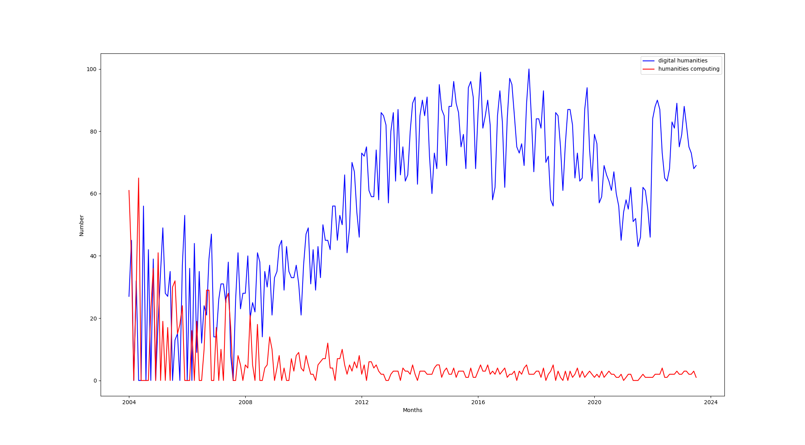

Figure 2 – Google trends: Humanities Computing and Digital Humanities.

There are several possible interpretations of these changes. The term *digital humanities* came up during exchanges between the editors and their publishers at Blackwell. It was a sort of rebranding: using an expression that seemed to be easily understandable (though – hence? – not that well defined), so that the book could reach a large audience. The introductory text of the *Companion* and other researchers (myself included) implicated the rise of the World Wide Web, which. began to constitute a digitization of the “human record.” In this context, the intertwining of data and networking could be seen as a foundation of the digital humanities movement. The switch corresponds with an increase in the number of newcommers (like myself in 2008): as *digital humanities* proved a wider net than *humanties computing* had ever been. Whether this shift drove the adoption of digital practices or was driven by it can be debated.

When Busa died a number of blogposts paid a tribute to his work, for instance by Stephen Ramsay.[15] Although Ramsay admits that Busa was part of a wider intellectual field, he claims for his importance and influence in Digital Humanities: “Perhaps the New Criticism was taking hold in some other part of the world, but for Busa, philology was the proper hermeneutical framework.” – a claim that situates the digital humanities in the conjunction of computers with a conservative European tradition, *cautioning* in advance later criticism of the field[16].

# A counter-history of Digital Humanities? The example of the Annales School

As Ramsay wrote in 2011, “Busa was one among the many who were striving to bring computer technology — then in its early infancy — to bear on humanistic problems back in the forties. Like most dh scholars today, he was part of a much wider intellectual network.” If we can admit that Busa was part of a wider intellectual field, why did his name became that central in Digital Humanities? Stephen Ramsay, quoting John Unsworth, seems to provide an answer: “Most disciplines can’t point to a founding moment, much less a divine one.” Beyond the divine argument, while some fragments of this intellectual network are considered today as *digital humanities* others are not. I will focus here on the French Annales School of history as an alternative and rarely considered tile in this historical mosaic.

In 1959, two French historians published an article that was the first one in a major French speaking history journal dealing with what was not yet called in French *ordinateur* (computer) or *informatique* (computing). Using “mécanographie”, François Furet and Adeline Daumard are explaining how they were able to deal with a massive data set, the notarial records of the 18th Century.[17] In 1961, in the same journal, two archaeologists cross-referenced two databases to yield more information on the Assyrian presence in Cappadocia[18]. Less focused on text than Busa’s work, the French historians followed the Annales tradition of working with large statistical series.[19] These scholars occasionally used the same computing facilities as Busa: the Euratom facilities in Ispra, Italy are explicitely mentioned by Garelli and Gardin as well as by Busa.[20] The use of mainframes and quantitative data fit quite well into the *longue durée* concept defined by Fernand Braudel in 1958.[21] A famous sentence by Le Roy Ladurie from an article in a French newsmagazine, *Le Nouvel Observateur*, described the future quantitative historian as necessarily a “programmer”.[22]

Quantitative history, as practiced by the 1960s generation, declined after the surge of microhistory[23] in the mid-1970s – a rise that can be interpreted as a switch from the search for patterns to the search for irregularities in details.[24] –Yet the early 2000s saw a new upsurge of quantitative methods based on large amounts of data[25]. In *Graphs, maps, trees*, Franco Moretti[26] tried to answer a simple question: how to write the history of European literature of the 18th and 19th centuries without limiting oneself only to “great novels” by “great authors”? How to write the history of a literature with too many novels for a historian to read? His answer: combining graphs (the Annales-style quantitative history), maps (inspired from geography) and trees (evolution) to create the concept of *distant reading*. This indirectly reintegrated the Annales in the digital humanities (though perhaps for this reason, the relationship of Moretti to the digital humanities has been debased despite the importance of his work to the field).[27]

This sort of integration of the Annales school within the digital humanities was confirmed by the publication of the *History Manifesto*, that tried, among other things, to renew Braudel’s idea of *longue durée*.[28] Drawing on the expansion of historical big data – massive digitization programs of historical documents –, Jo Guldi and David Armitage have advocated for a return to the *longue durée* as a solution to widespread narrowing of the timescale of historical work. This brings us full circle, from the Annales school as a precursor to the digital humanities to the digital humanities driving a return to study of the *longue durée.*

The fact that the 1950s and 1960s generations of Annales historians were not considered part of the *humanities computing* or *digital humanities* despite using the same facilities as the researcher acknowledged as the “founding father” of those same academic strands, underscores that the *digital* is not the only element that shaped the definition of those fields.

# Digital Humanities as revolution?

According to a “manifesto on manifestos” from 2008-2009[29] the example of the Annales School – which was belonging to the Humanities and to computing / digital but not seen as Humanities Computing or Digital Humanities at its beginning – shows that the specificities of the Digital Humanities might not lie in the digital nor the humanities *per se*.

Digital Humanities is not a unified field but an array of convergent practices that explore a universe in which: a) print is no longer the exclusive or the normative medium in which knowledge is produced and/or disseminated; instead, print finds itself absorbed into new, multimedia configurations; and b) digital tools, techniques, and media have altered the production and dissemination of knowledge in the arts, human and social sciences. The Digital Humanities seeks to play an inaugural role with respect to a world in which, no longer the sole producers, stewards, and disseminators of knowledge or culture, universities are called upon to shape natively digital models of scholarly discourse for the newly emergent public spheres of the present era (the www, the blogosphere, digital libraries, etc.), to model excellence and innovation in these domains, and to facilitate the formation of networks of knowledge production, exchange, and dissemination that are, at once, global and local.

Nevertheless, the text then turns into a revolutionary manifesto about practices – how to set up a revolution, how to change academia, how to valorize community/teamwork, how to democratize knowledge, how to get knowledge out of Universities. The claim that the digital humanities are related to the Californian counterculture is quite central, though the work of Fred Turner[30] suggests that it might be more ambiguous than the authors thought, or maybe was it obvious to their eyes that *digital* was linked to the meaning Negroponte gave to it as explained in a previous chapter of this book. In this text, DH is more an avant-garde community than a community based on digital tools or computing, though the *digital* is part of this avant-garde. Even the far more digital-centered Parisian *Manifeste des Digital Humanities* (of which the author of this chapter modestly contributed) focuses on community and interdisciplinarity and not only on the use of digital tools.

# Conclusion: a multilayered digitality?

I have tried to explain in this chapter that *digital humanities* are not only about digitality and humanities – but also a lot about practices, community, academia and how to change it. There is an internal contradiction within a community that embraces at the same time a *godfather* from the Catholic church and the claim of a revolutionary rupture. Maybe this contradiction can be compared to the one that Thomas Haigh notes in Negroponte’s 1995 book, where claims were at the same time futuristic and conservative. In this sense digital humanities may not be an exception.

Statistics were the *big data* of humanities research in the 1960s. The fact that *humanities computing* and then *digital humanities* were not necessary only *digital* explains why parts of the humanities, including a school as important as the Annales, were not until recently considered part of those traditions.

Ultimately, the *digital* that sets the *digital humanities* aside from other humanities fields might, as Milad Doueihi implied, relate more to culture than the use of computers in Humanities, they also set specific practices, even, maybe, specific set of research questions, etc (more collective, more community-ish, supposed to be more open), though it has been true for other kind of practices (academic associations) in Humanities. The digital humanities are as much characterized by non-digital elements than by digital ones, but non-digital elements are still partly based on encounters with the computer. In this sense, we could speak about a multilayered *digitality*:

* digital in the sense of computers, as there’s no *digital humanities* without computers,
* the transformation of this computational use in the Humanities into cultural digital objects such as wikis,
* the emergence of practices around those cultural digital objects.

I therefore subscribe to an extended definition of *digital* and *digitality* grounded more in the work of Doueihi than Negroponte. Following Doueihi, I would advocate for a form of digital humanism, encompassing the realm of digital humanities: as Levi-Strauss identified three humanism (the aristocratic Renaissance Humanism, the bourgeois exotic humanism of the XIXth century and the democratic humanism of the XXth Century), *digital humanism* would be a fourth humanism, seen as a place of hybridity, of convergence of a complex cultural legacy and a set of technologies that are now present in all aspects of our lives.

1. We refer to THATCamp 2009. For a definition of THATCamps, please go to the now archived website: <https://thatcamp.org/about/index.html>. The anecdote here dates back to [THATCamp CHNM 2009](https://chnm2009.thatcamp.org/). One related blog can be read here: <https://chnm2009.thatcamp.org/06/25/us-vs-them/index.html>. The anecdote is narrated as it happened according to the author’s memory – it might have happened otherwise.
2. Lisa Spiro, « “This Is Why We Fight”: Defining the Values of the Digital Humanities », in *Debates in the Digital Humanities*, éd. par Matthew K. Gold (University of Minnesota Press, 2012), 16‑35, https://doi.org/10.5749/minnesota/9780816677948.003.0003.
3. Niels Brügger, *The Archived Web: Doing History in the Digital Age* (Cambridge, MA, USA: MIT Press, 2018), 17.
4. Quoted by Brügger: Finnemann, N. O. (1999). Modernity modernised: The cultural impact of computerisation. In P. A. Mayer (Ed.), Computer, media and communication (pp. 141–159). Oxford: Oxford University Press.
5. Milad Doueihi, *Pour un humanisme numérique*, Washing machine (Paris: publie.net, 2012).
6. Susan Schreibman, Ray Siemens, et John Unsworth, éd., « The Digital Humanities and Humanities Computing: An Introduction », in *A companion to digital humanities* (Blackwell Publishing, 2004), https://companions.digitalhumanities.org/DH/?chapter=content/9781405103213_foreword.html.
7. Max Reinert, « Les “mondes lexicaux” et leur “logique” à travers l’analyse statistique d’un corpus de récits de cauchemars », *Langage et société* 66, no 1 (1993): 5‑39, https://doi.org/10.3406/lsoc.1993.2632.
8. For that, research, rather recent, do exist: Chris Alen Sula et Heather V Hill, « The Early History of Digital Humanities: An Analysis of Computers and the Humanities (1966–2004) and Literary and Linguistic Computing (1986–2004) », *Digital Scholarship in the Humanities*, 5 novembre 2019, fqz072, https://doi.org/10.1093/llc/fqz072; Julianne Nyhan et Melissa Terras, « Uncovering ‘hidden’ contributions to the history of Digital Humanities: the Index Thomisticus’ female keypunch operators », in *Digital Humanities 2017* (Montréal, QC, Canada, 2017), 313‑15.
9. Maurice Halbwachs, *Les cadres sociaux de la mémoire / Maurice Halbwachs ; postf. de Gérard Namer*, Bibliothèque de l’évolution de l’humanité 8 (Paris: Albin Michel, 1994).
10. Roberto Busa, « Foreword: Perspectives on the Digital Humanities », in *A companion to digital humanities*, éd. par Susan Schreibman, Ray Siemens, et John Unsworth (Blackwell Publishing, 2004), https://companions.digitalhumanities.org/DH/?chapter=content/9781405103213_foreword.html.
11. Matthew Kirschenbaum, « “Chapter 1: What Is Digital Humanities and What’s It Doing in English Departments? | Matthew Kirschenbaum” in “Debates in the Digital Humanities” on Debates in the DH Manifold », in *Debates in the Digital Humanities*, 2012.
12. Schreibman, Siemens, et Unsworth, « The Digital Humanities and Humanities Computing: An Introduction ».
13. Busa, « Foreword: Perspectives on the Digital Humanities ».
14. While its website is no more available, it remains as an archive: <https://web.archive.org/web/20060705200829/http://www.allc-ach2006.colloques.paris-sorbonne.fr/>
15. Stephen Ramsay, « Fr. Roberto Busa, S.J. (1913-2011) », Blog, *Stephen Ramsay* (blog), 11 août 2011, https://web.archive.org/web/20121015012201/http://stephenramsay.us:80/2011/08/11/father-roberto-busa.html.
16. Daniel Allington, Sarah Brouillette, et David Golumbia, « Neoliberal Tools (and Archives): A Political History of Digital Humanities », *Los Angeles Review of Books*, 5 janvier 2016, https://lareviewofbooks.org/article/neoliberal-tools-archives-political-history-digital-humanities/.
17. François Furet et Adeline Daumard, « Méthodes de l’Histoire sociale: les Archives notariales et la Mécanographie », *Annales ESC* 14, no 4 (1959): 676‑93, http://www.persee.fr/web/revues/home/prescript/article/ahess_0395-2649_1959_num_14_4_2865.
18. Paul Garelli et Jean-Claude Gardin, « Étude par ordinateurs des établissements assyriens en Cappadoce », *Annales ESC* 16, no 5 (1961): 837‑76, http://www.persee.fr/web/revues/home/prescript/article/ahess_0395-2649_1961_num_16_5_420758?luceneQuery=%28%28%2B%28cappadoce%29+%2B%28ordinateurs%29%29+AND+%28+%2Baccess_right%3A%28free%29+%29%29+AND+%28indexable_type%3Aarticlepag%3F%29&words=cappadoce&words=ordinateurs&words=free&words=articlepag.
19. See for instance : Emmanuel Le Roy Ladurie, *Les Paysans de Languedoc* (Paris: SEVPEN, 1966).
20. For more information on the Euratom facilities at Ispra and Digital Humanities: Edgar Lejeune, « Euratom et la genèse des humanités numériques en Europe (1957-1970) | EHNE », in *Encyclopédie d’histoire numérique de l’Europe*, 3 novembre 2022, https://ehne.fr/fr/node/21774.
21. Fernand Braudel, « Histoire et Sciences sociales : La longue durée », *Annales. Économies, Sociétés, Civilisations* 13, no 4 (1958): 725‑53, https://doi.org/10.3406/ahess.1958.2781.
22. Emmanuel Le Roy Ladurie, « La fin des érudits », *Le Nouvel Observateur*, 5 août 1968, http://hebdo.nouvelobs.com/sommaire/arts-spectacles/077609/la-fin-des-erudits.html.
23. Carlo Ginzburg, *Il formaggio e i vermi: il cosmo di un mugnaio del ’500*, Biblioteca Einaudi 71 (Torino: Einaudi, 1999).
24. Louise Bacquet, « Le paradigme indiciaire chez Ginzburg », *Témoigner. Entre histoire et mémoire. Revue pluridisciplinaire de la Fondation Auschwitz*, no 121 (1 octobre 2015): 175, https://doi.org/10.4000/temoigner.3555.
25. we should state here that quantitative methods never disappeared. What we define here as “quantitative” is rather a question of how to find patterns in large amounts of data.
26. Franco Moretti, *Graphs, Maps, Trees: Abstract Models for Literary History* (Verso, 2007).
27. Franco Moretti did not really belong to DH: Ted Underwood recalls us that distant reading, the key concept pushed forward by Moretti, is of a different genealogy than Digital Humanities (Ted Underwood, « A Genealogy of Distant Reading », *Digital Humanities Quarterly* 011, no 2 (27 juin 2017).), all the more that distant reading is not obligatory *digital* or, in other words, is not obligatory computer-based. But his book’s popularity in DH could be explained by the conjunction of several factors, including the fact that the coming of big data in the 2010s led to a renewal of quantitative approaches, as well as the coming to maturity of AI-based technologies and algorithms such as machine and deep learning.
28. Jo Guldi et David Armitage, *The History Manifesto* (Cambridge, United Kingdom: Cambridge University Press, 2014).
29. Manifesto 2009, « The Digital Humanities Manifesto 2 », 2009 2008, Manifesto 2009 “Digital Humanities Manifesto 2.0.” 2009. http://www.humanitiesblast.com/manifesto/Manifesto_V2.pdf.
30. Fred Turner, *From Counterculture to Cyberculture: Stewart Brand, the Whole Earth Network, and the Rise of Digital Utopianism*, 1re éd. (University Of Chicago Press, 2006).